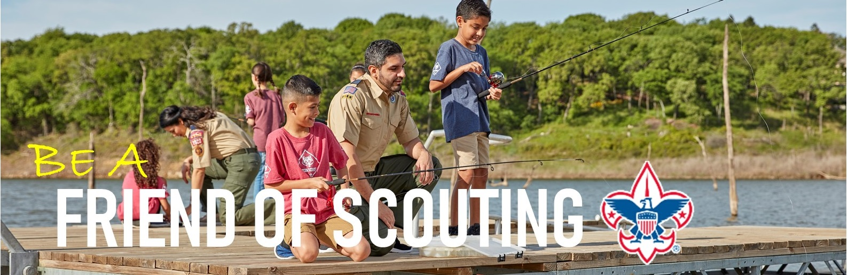
Pre- Communication Letter

To the parents of (UNIT AND NUMBER):

On (DATE or EVENT) we will be having our Family Friends of Scouting (FOS) presentation. Friends of Scouting is the one time each year when families are asked to make a financial investment to support the Dan Beard Council and local Scouting programs.

As a member of (PACK/TROOP #), you are asked you to pay an annual registration fee, which goes directly to national registration dues and insurance costs. You may also be asked to provide dues to the pack or troop each year. However, Family Friends of Scouting dollars go toward directly impacting local youth and Scouting programs. Friends of Scouting helps to support local “behind the scenes” expenses that our Dan Beard Council incurs: operating costs for Camps Friedlander, Cub World, Craig and Michaels, programs and activities like Pinewood Derby, Cub-o-ree, Merit Badge Days, Spook-O-Ree, Peterloon, Camp Staff, Adult Leader Training and much more. Family FOS donations also provide Camperships for Scouts who are unable to afford the experience and help to fund our local outreach programs.
It takes about $210 to provide your Scout with the services and programs offered each year. Please consider how much your child and other Scouts benefit from Scouting when making your decision. In 2022, we hope to have 100% participation; and we need your help!
At the presentation you will receive a Friends of Scouting pledge card and will learn more. If you cannot make the presentation, would like to learn more in advance, or want to give online, please visit www.danbeard.org/FOS.
I believe in Scouting and that supporting our local program is important. Please join me join me and thousands of other families by giving a gift to the Friends of Scouting campaign. Every little bit helps and together we can help to cover the costs of these important resources that are provided to our kids each year. Show that you too Believe in Scouting’s impact.
FOS Unit Champion (or presenter)
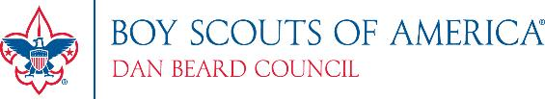

To the parents of (UNIT AND NUMBER): Post Communication Letter

On DATE we held a Friends of Scouting presentation. I want to thank all of those in attendance who made a financial investment to support the Dan Beard Council. Your contribution ensures that we can keep Scouting strong for more than 30,000 local participants.

Some of you were unable to make the presentation or did not turn in your card that night. We need your help! Friends of Scouting dollars go toward “behind the scenes” expenses that Dan Beard Council incurs during the year, initiatives that our (PACK/TROOP) take advantage of. This includes District and Council programs, camp enhancements for Camps Friedlander, Cub World, Craig, and Michaels, and other major activities like Peterloon and Merit Badge Challenge. Friends of Scouting investments also provide the program to kids that would otherwise be unable to afford participation. Dan Beard Council serves more than 30,000 youth in a 12-county region and delivers one of the strongest Scouting programs in the entire country.

I want to ask all of you who have not made an investment to do so today. Please take a moment to return your pledge card, or you if you would like to learn more or make a contribution online, please visit www.danbeard.org/FOS. Thank you in advance for your generous contribution. Every contribution helps the cause. Please join me in making sure all of our youth have the opportunity to be a Prepared. For Life. Thanks for your support!

FAMILY FOLLOW-UP LETTER
This letter can be mailed from the Council to each family within a unit that did not give immediately
following each unit presentation. District Executive’s must initiate this letter with Field Service Assistant. Date
Name
Address
City, State Zip

Dear name:
As a fellow Scout parent, I think you’d agree that Scouting is not only one of the finest youth development programs in the world, but it’s also FUN! The Dan Beard Council, Boy Scouts of America is able to provide a quality program to our youth because of the support received from Scout parents like you.
The annual Friends of Scouting campaign provides training for our leaders, insurance, program support, and maintenance of our four camping facilities, among many other things. The Dan Beard Council depends on the Friends of Scouting campaign for over one third of its operating budget. It is essential to the well-being of the Scouting program for your child.
This past week Pack/Troop # had a Friends of Scouting presentation, but we did not receive a pledge from you. As a Scouting parent, I wanted to send you a personal letter asking you to join me in supporting a quality Scouting program for our boys.

Please consider an investment in Scouting. We ask that each family consider donating $210, as this is the minimum cost to the Council for each Scout. There is a special edition Council Shoulder Patch for those who contribute $210 or more and it will be mailed to you upon receipt of your pledge. Of course every gift is important and any amount that you can give is gratefully appreciated. Our hope is that 100%
of our parents will contribute at some level.
In an effort to wrap-up our campaign, please return the enclosed pledge card at your earliest convenience, or you can make a contribution online at www.danbeard.org/donate. Thank you in advance for your generous contribution.
Yours in Scouting, Dan Beard Council
Family Friends of Scouting Chair
P.S. If you have already made a gift to Scouting or our correspondence has crossed in the mail, please accept our thanks for your support!

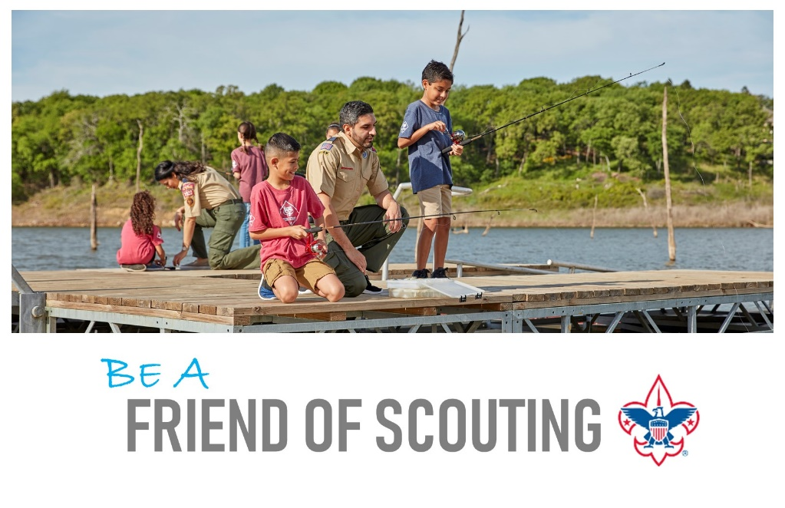
FAMILY 2nd CHANCE LETTER

Date

Name
Address
City, State Zip

Dear name:

The Boy Scouts of America teaches young people to make positive choices by following the values of the Scout Oath and Law. Last year, the Dan Beard Council proudly awarded 372 young men the rank of Eagle Scout. Annually, our Scouts donated over 196,000 of community service for those in need.

The Dan Beard Council truly appreciates your past support. Your generosity helps to provide Scouting with four year-round camping facilities, leader training, Scout recruiting, and program development. Last year, you made a gift of $. Please consider renewing your investment through this year’s Friends of Scouting Campaign.

As we prepare for a busy fall of campouts and activities, our goal is to conclude the campaign by the end of the month. Please use the enclosed pledge card and return envelope to make your tax-deductible investment in Scouting today. You can also make a contribution online at www.danbeard.org/donate. Thank you for your consideration and support of the Boy Scouts of America.

Best Regards,

Friends of Scouting Chair

P.S. If you have already made a gift to Scouting or our correspondence has crossed in the mail, please accept our thanks for your support!

ALUMNI FOLLOW-UP LETTER

Dear <UNIT> Alumni:

Several years ago, your son was involved in the Scouting Program. We trust that he can look back with pleasure and you with pride on the experiences and values Scouting provided during that formative time in your son's life.

I am writing to you, as a volunteer Scout leader and on behalf of the Friends of Scouting Campaign. The Dan Beard Council depends on the Friends of Scouting Campaign for over a third of the funding needed to provide the values Scouting brings to young people throughout our 12-county area. In fact, Friends of Scouting is the largest source of funding for the Scouting Program.

We need your help. In addition to the dues a Scout pays, it costs $210 to support each child in Scouting for a year. You can make a contribution that will play an important part in helping us to continue Scouting for other young people. I hope that you can help us in this important work. I've enclosed a Friends of Scouting card, and ask you to complete and return it for whatever amount you are able to pledge. You can also make a contribution online at www.danbeard.org/FOS.

On behalf of the young leaders in the Dan Beard Council, for whom the Scouting program is so valuable in their formative years, I'd like to say - THANK YOU!

Sincerely,

Unit Campaign Champion

